**Company Profile**

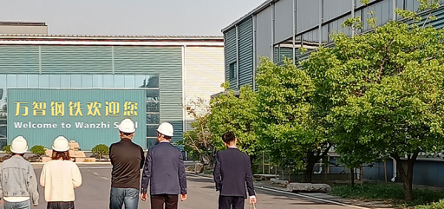

Wanzhi Steel is a leading steel product producer in China, coordinating sales, warehousing, deep processing, distribution, export to meet customers' needs for steel supply chain.

Our office is located in Zhengzhou, Henan Province, and the factory is located in Shandong Province, close to Qingdao Port. Our products cover carbon steel, stainless steel, cold rolled steel and hot rolled steel, GI, GL, PPGI, PPGL, corrugated roofing sheets, angle steel, rebar, steel pipe, steel strip, etc., customized according to customer requirements.

**Colour coated roofing sheet Product Introduction**

Color coated roofing sheet are made of color-coated steel plates, which are rolled and cold-bent into various corrugated profiles.

It is suitable for industrial and civil buildings, warehouses, special buildings, roofs, walls, and interior and exterior wall decoration of large-span steel structure houses. It has the characteristics of light weight, high strength, rich colors, convenient and fast construction, earthquake resistance, fire resistance, rain resistance, long life, and maintenance-free. It has been widely promoted and applied.

**Colour coated roofing sheet Model**

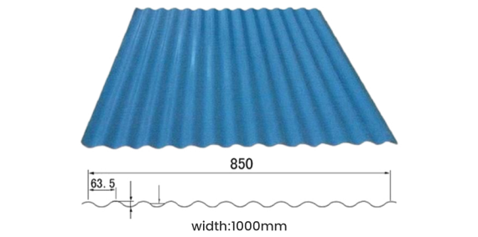

|  |  |  |  |
| --- | --- | --- | --- |
| Model | Wanzhi-14-63.5-850 | | |
| Effective Width(mm) | 850 | | |
| Overall Width(mm) | 1000 | | |
| Thickness(mm) | 0.5 | 0.6 | 0.8 |
| Sectional Moment of Inertia(cm4/m) | 1.84 | 2.25 | 3.04 |
| Section Resistance Moment(cm³/m) | 2.04 | 2.50 | 3.37 |

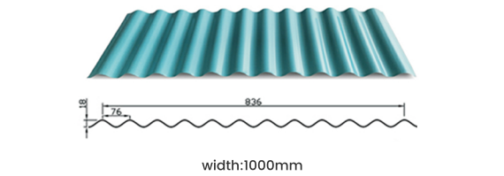

|  |  |  |
| --- | --- | --- |
| Model | Wanzhi-18-76-836 | |
| Effective Width(mm) | 836 | |
| Overall Width(mm) | 1000 | |
| Thickness(mm) | 0.5 | 0.6 |
| Sectional Moment of Inertia(cm4/m) | 2.45 | 2.94 |
| Section Resistance Momentt(cm³/m) | 2.57 | 3.07 |

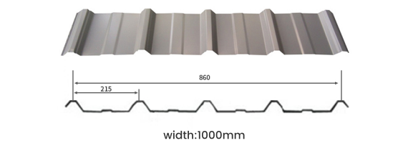

|  |  |  |  |
| --- | --- | --- | --- |
| Model | Wanzhi-20-215-860 | | |
| Effective Width | 860 | | |
| Overall Width(mm) | 1000 | | |
| Thickness(mm) | 0.5 | 0.6 | 0.8 |
| Sectional Moment of Inertia(cm4/m) | 8.01 | 10.74 | 14.02 |
| Section Resistance Moment(cm³/m) | 3.62 | 5.92 | 7.98 |

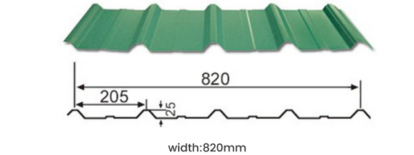

|  |  |  |
| --- | --- | --- |
| Model | Wanzhi-25-205-820 | |
| Effective Width(mm) | 820 | |
| Overall Width(mm) | 1000 | |
| Thickness(mm) | 0.5 | 0.6 |
| Sectional Moment of Inertia(cm4/m) | 4.38 | 5.32 |
| Section Resistance Moment(cm³/m) | 7.18 | 8.55 |

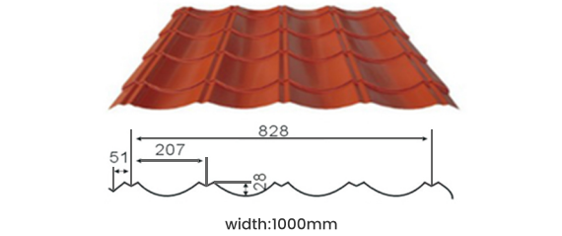

|  |  |  |
| --- | --- | --- |
| Model | Wanzhi-28-207-828 | |
| Effective Width(mm) | 850 | |
| Overall Width(mm) | 1000 | |
| Thickness(mm) | 0.5 | 0.6 |
| Sectional Moment of Inertia(cm4/m) | 14.8 | 17.76 |
| (Section Resistance Moment(cm³/m) | 12.32 | 14.76 |

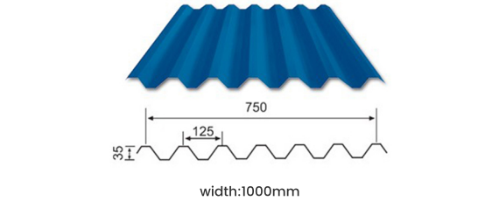

|  |  |  |
| --- | --- | --- |
| Model | Wanzhi-35-125-750 (V-125) | |
| Effective Width(mm) | 750 | |
| Overall Width(mm) | 1000 | |
| Thickness(mm) | 0.5 | 0.6 |
| Sectional Moment of Inertia(cm4/m) | 11.54 | 13.85 |
| Section Resistance Moment(cm³/m) | 6.23 | 7.48 |

Wanzhi Steel Group is now able to produce color-coated roof panels. If you need customization, you can provide the tile pattern and we can customize it for you.

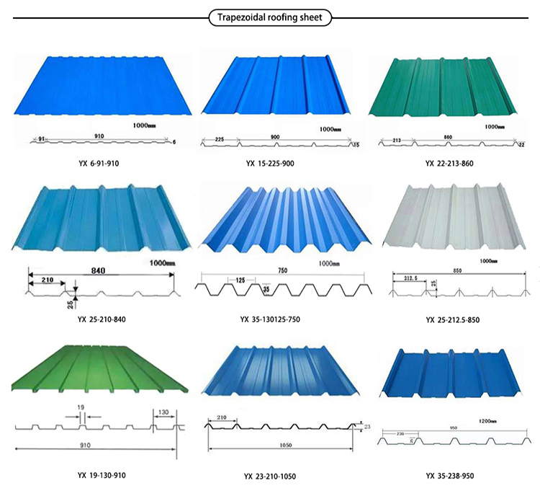

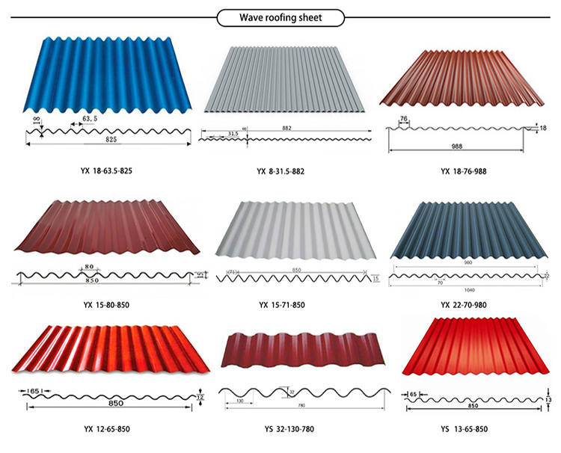

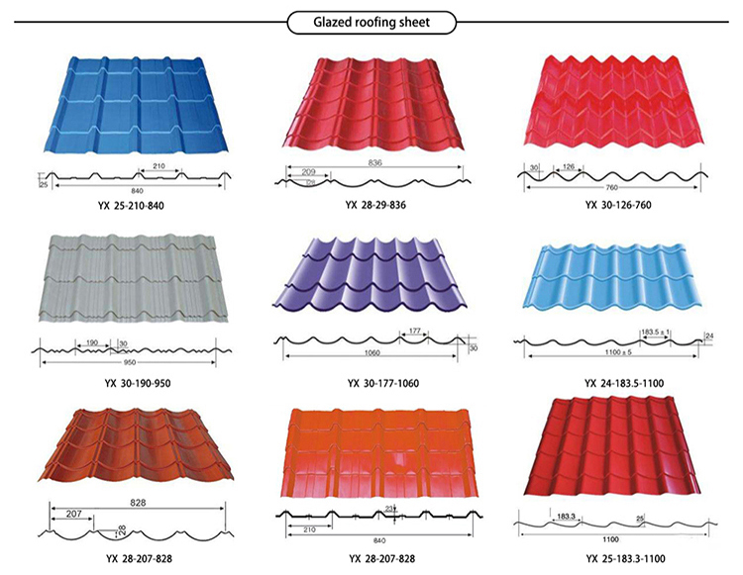

**contact us**

**This is our website: https://wzppgi.com/**

**My WhatsApp: +8615138685087**

**My Email: inquiry02@wanzhisteels.com**

**Welcome contact us at any time.**